2024 Participant Handbook

The RCPAQAP welcomes you to our 2024 enrolment year
Dear Customer,
Welcome to the 2024 enrolment year. We are introducing a number of new EQA programs in 2024 and you can find these details here in our online product catalogue. All EQA programs are now on the new myQAP portal, and we have continued to develop the analytics capability to improve the value of our products.
I continue to acknowledge the input into our programs from the Fellows, our Board of Directors, and Scientists on our many Advisory Committees. They continue to provide us with expert and contemporary knowledge on the problems laboratories face and how we should tailor our programs to ensure our EQA programs meet your needs.
As always, we aim to provide you with the best-in-class EQA programs that facilitate the assessment of performance by peer group comparison.

With regards

Tony Badrick

Chief Executive Officer
The Royal College of Pathologists of Australasia Quality Assurance Programs (RCPAQAP)
Suite 201/8 Herbert Street
St Leonards, NSW 2065
Ph: +61 2 9045 6002 | Mobile: 0435 416 022
Website: www.rcpaqap.com.au

RCPAQAP Overview
RCPA Quality Assurance Programs are world leaders in the provision of external quality assurance (EQA) for pathology laboratories. We offer a comprehensive range of EQA for all disciplines of pathology including Molecular Genetics, Biosecurity and Point-of-Care. Our programs are offered in Australia and internationally in over 80 countries. RCPAQAP is committed to providing an efficient and customer focused service to participants.
Participants are provided with regular and frequent challenges, peer reviewed assessment and educational activities to monitor the quality of their laboratory services ensuring they meet accreditation requirements. Our strength lies in the expertise and support provided by an extensive advisory network consisting of pathologists and scientific staff from Australia and internationally.

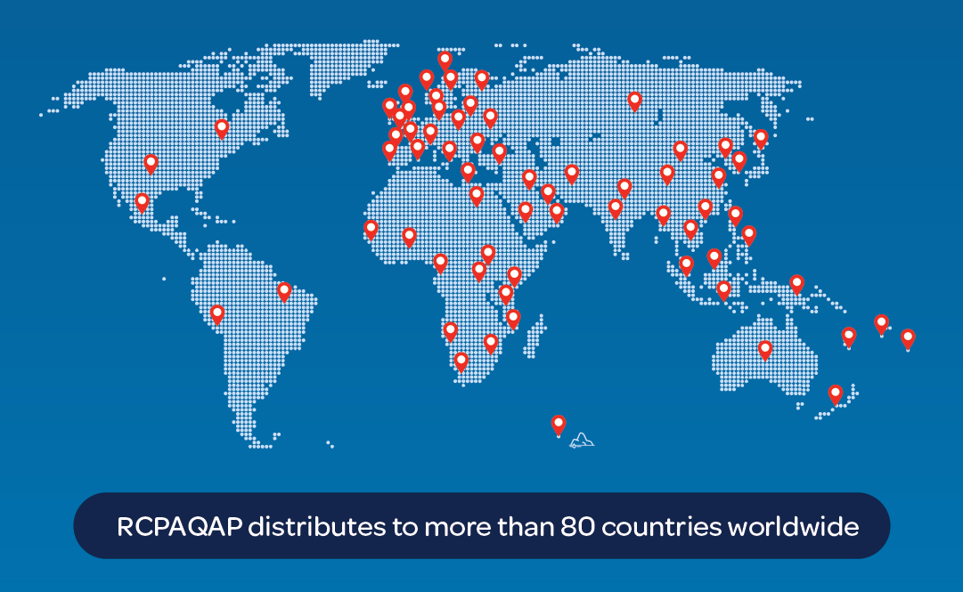

Accreditation
ISO/IEC 17043:2010  The RCPAQAP is accredited for compliance to ISO/IEC 17043 Conformity assessment – General requirements for proficiency testing.    Accreditation Number: 14863 |  |  | ISO 9001:2015  The Company, including all disciplines and support services are certified to ISO 9001:2015 Quality management systems  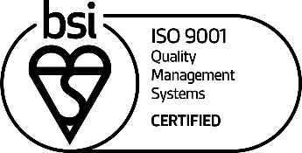  FS 605318
 | ISO 14001:2015  The Company, including all disciplines and support services are certified to ISO 14001:2015 Environmental management systems  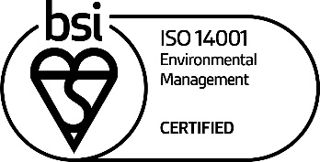  EMS 685459 |  | ISO 45001:2018  The Company, including all disciplines and support services are certified to ISO 45001:2018 Occupational Health and Safety management systems  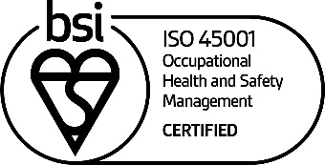  OHS 700066

RCPAQAP Policies
RCPAQAP polices are available on our website.
Quality Policy
Work Health & Safety Policy
Environmental Sustainability Policy

The RCPAQAP Team
The RCPAQAP is committed to providing quality programs and excellent customer service to assist participants.

Tony Badrick Chief Executive Officer (CEO)
Derek Holzhauser Chief Information Officer
Zoe Vayanos Manager Operations
Megan Cooke Manager Alliance and Partnerships
Wayne Randle Head of Infrastructure
Michelle Keays Manager Marketing and Communications
Jennifer Ross Manager Quality
John Sioufi Manager User Experience
Anthony Green Manager IT Systems
Allison Terrell Manager Laboratory Facilities and Procurement
Rhys Judd Manager Customer Service
Julia Pagliuso Head of Tissue Disciplines and Molecular Genetics
Peter Graham Head of Blood Disciplines
Torsten Theis Head of Microbiology Disciplines
Stephanie Gay Co-ordinator KIMMS

For all enquiries log a request in the myQAP portal.

RCPAQAP Advisory Committees
The program advisory committees meet at least annually to discuss a range of issues critical to the ongoing development and enhancement of the programs. Group performance, and participant feedback is reviewed and samples are selected for the following year’s surveys. The responsibilities of the committees may include but are not limited to:
- Provision of expert opinion on documents and policies
- Provision of advice on all clinical and scientific aspects of the program surveys
- Provision of survey material
- Provision of expert commentary on reports
- Provision of educational material
- Provision of advice about relevant new tests and initiatives in the discipline
- Provision of advice about other activities, as deemed appropriate by the committee

The program Advisory Committee Chairs are listed below:
Beena Kumar Anatomical Pathology and Cytopathology
William Rawlinson Biosecurity
Chris Farrell Chemical Pathology
Shaun Donovan Cytopathology
John Giannoutsos Haematology
Frederick Lee Immunology
David Roxby KIMMS
Juliet Elvy Microbiology and Molecular Infectious Diseases
Eric Lee Molecular Genetics
Meryta May Serology
Neil McGill Synovial Fluid
Anastazia Keegan Transfusion

Subcontractors
Some aspects of the RCPAQAP proficiency testing schemes may at times be subcontracted. Services which may be subcontracted include sample preparation and the professional review of results. When subcontracting occurs, it is placed with a competent subcontractor, however, the RCPAQAP is ultimately responsible to participants for the subcontractor’s work.

RCPAQAP General Information

Schedule
The RCPAQAP is pleased to announce the implementation of the Calendar Tab in the myQAP portal. The calendar includes survey open and close dates for all RCPAQAP programs.
The enhancement will give you the ability to customise your calendar information and download it to either your Google, Apple or Outlook calendars or as a CSV file. As updates to the survey schedule are not applied automatically to the downloaded CSV file, we recommend that you download the survey dates to your email calendar. For further information please refer to the Video help guide

Enrolment Certificate
Once your enrolment has been processed in the myQAP portal, an invoice is automatically generated. Once this invoice has been paid in full, the Enrolment Certificate is automatically sent to your laboratory. Please contact the RCPAQAP via Requests in myQAP if you have finalised your invoice but have not received your Certificate.

Participation Certificate
Participation Certificates for the current year are available in the myQAP portal for participating laboratories at the end of the survey cycle or calendar year. Surveys are itemised and indicate whether responses were returned for those surveys in which participants were enrolled.
On receipt, check your certificate for accuracy and completeness.

Your Contact Details
It is the responsibility of each participant to ensure that contact details held by the RCPAQAP are up to date. This is managed by participants, or your regional distributor, in myQAP. To ensure that access is permitted only to appropriate individuals and that correct participant details are maintained, the RCPAQAP has developed the following ‘Add a contact’ policy:
- A new participant contact can be added by an existing primary contact in the portal using the ‘Add contact’ facility.
- A new participant contact can be added by an existing participant contact by logging a Request in the portal and providing the following information;
    - new contact’s name, email address, phone number and role.
    - The participant(s) (include discipline and participant number) to which the contact is to be associated.
    - the access profile (full, limited or ‘result entry only’) that is to be assigned.
It is essential that the RCPAQAP is notified of any contacts that leave an Organisation/Site/Laboratory so that the user’s profile can be either disassociated or deactivated, depending on the situation. These notifications must be received in writing by logging a ‘Request’ in myQAP. Failure to do this could result in a breach of confidentiality as the person will still have access to the Organisation/Site/laboratory details. The RCPAQAP accepts no responsibility for users still having access to myQAP if RCPAQAP has not been notified that the contact no longer works for that organisation. If in the reasonable opinion of the RCPAQAP, the organisation fails to comply with Portal User Agreement, RCPAQAP reserves the right to cancel or restrict access to myQAP. To view the Portal user Agreement click here. Those customers who have a local distributor will need to contact their them or log a Request to add, disassociate or deactivate a contact.

RCPAQAP Terms of Trade
To view the Terms of Trade click here.

RCPAQAP Privacy Policy
If you have questions about RCPAQAP and privacy, wish to provide feedback on this policy, would like to update your personal details or wish to access personal information held by RCPAQAP about you, please contact privacy@rcpaqap.com.au. Please click the here to view the Privacy Policy and Cookies Policy.

Copyright
The use of RCPAQAP materials such as survey materials, images and reports are subject to copyright. The material may not be reproduced in whole or in part for any purpose whatsoever (including presentations at meetings and conferences), without the prior written permission of the RCPAQAP. Permission must be sought in writing from the Discipline Manager, Chair or CEO, but will not be reasonably refused, except on ethical grounds or in cases where there is a financial or other incentive awarded to others. The RCPAQAP must be acknowledged for all material reproduced, distributed or displayed.

Homogeneity & Stability
The RCPAQAP is committed to providing participants with test material that is both homogeneous and stable and complies with ISO/IEC 17043:2010 Conformity assessment - General requirements for proficiency testing and ISO 13528:2015 Statistical methods for use in proficiency testing by interlaboratory comparison.
Samples sent as test material in the external quality assurance programs are tested for homogeneity and stability, except where limited volume or other factors preclude the RCPAQAP from performing the testing.
Where new programs are introduced, an initial homogeneity and stability testing study may be required to establish that test material is both homogeneous and stable.
Where homogeneity and stability testing has been conducted for many years, testing may be reduced, as necessary, utilising historical data and participant data to ensure homogeneity and stability.
Where test material fails to pass homogeneity and stability criteria, that sample will not be assessed. However, the sample may still be used for educational purposes, if appropriate.

Participation in RCPAQAP Programs
Laboratories participating in RCPAQAP programs receive proficiency test items and report their results back to the RCPAQAP. Participants receive notification of the accuracy of their results from the RCPAQAP after results from all participants are evaluated.
Participants should test proficiency test items in the same manner as patient specimens.
- The proficiency test items should be examined or tested with the laboratory's regular patient workload by personnel who routinely perform the testing in the laboratory, using the laboratory's routine methods. The laboratory manager must attest to the routine integration of the proficiency test items into the patient workload using the laboratory's routine methods;
- The participant should examine proficiency test items the same number of times that it routinely examines patient samples;
- Participants who examine proficiency test items should not engage in any inter-laboratory communications pertaining to the results of these until after the closing date;
- Participants with multiple testing sites or separate locations should not participate in any communications or discussions across sites/locations concerning proficiency testing specimen results until after the final results are received unless this is routine practice e.g. subspecialty groups within an Anatomical Pathology organisation;
- The participant should not send proficiency test items or portions of same to another laboratory for any analysis that it is accredited to perform in its own laboratory;
- The participant should maintain a copy of all records to record proficiency testing results. This documentation should be retained for the minimum timeframe as set out in local regulatory requirements.

Participant Responsibilities
- Participants have an obligation to enrol in, and return all results for, the appropriate modules.
- The RCPAQAP evaluates performance in comparison to participating laboratories. The program does not permit falsification or collusion of survey results. Participants are reminded to treat survey samples as closely as possible to patient samples.
- The information on the reports is subject to strict copyright and must not be used without permission. The information may not be reproduced in whole or in part for any purpose whatsoever (including presentations at meetings and conferences), without the prior written permission of the RCPAQAP. Permission must be sought in writing from the relevant RCPAQAP Section Head or Manager and will not be unreasonably refused. The participant must acknowledge the RCPAQAP in any publication where intellectual property of the RCPAQAP has been used or quoted. The participant must provide to the RCPAQAP a copy of any publication in which data is used or quoted.
- Participants are always responsible for their own policies, decisions and outcomes. RCPAQAP is not a regulatory body, but we hope to share education, interest and knowledge. The key to our success as service providers is interaction, communication and consistency.
- Participants should check reports as soon as they are received. If a report is incorrect or if there are any queries regarding the results, contact RCPAQAP via the myQAP portal immediately. Any issues that require clarification will be escalated to the relevant RCPAQAP Chair or Advisory Committee.
- Keep address and contact information current, refer to Your Contact Details in this handbook.

RCPAQAP Survey Materials/Proficiency Test Items
Many countries require the recipient of RCPAQAP proficiency test items to have an import permit.
It is the participant’s or regional distributor’s responsibility to verify with their local authorities if they require an import permit.
Proficiency test items will be dispatched according to the date on the dispatch schedule. Participants must ensure there is a valid import permit for this period of time. If the proficiency test items are delayed in transit, their integrity cannot be guaranteed and no refunds will be issued for proficiency test items that have perished due to customs clearance delays associated with a lack of a valid import permit.
Import duties, taxes and charges are not included in the enrolment and shipping price. These charges are the participant's responsibility.

Packaging of RCPAQAP Proficiency Test Items
All shipments comply with Australian Government, International Air Transport Association (IATA) and International Civil Aviation Organization (ICAO) regulations and all necessary documentation is included with each shipment.
Most proficiency test items dispatched by RCPAQAP are classified as ‘Exempt human specimen’, and packaging is marked accordingly.
The remainder of the shipments are classified as UN3373 Biological Substances, Category B, with the exception of the RCPAQAP Biosecurity proficiency tests, these are classified as UN2814, Infectious Substances affecting humans and/or UN3172, Toxins, extracted from living sources, liquid, or not otherwise specified.
Some shipments may require UN1845 Dry Ice, this is indicated in the Product Catalogue.

Labelling of RCPAQAP Proficiency Test Items
All RCPAQAP proficiency test items are labelled with unique identifiers to ensure participants select the correct proficiency test item for the correct test event.
Proficiency test items that are stored frozen pre-survey open date, are labelled with thermal transfer cryolabels that offer premium adhesion properties at low temperature conditions.

On arrival of RCPAQAP Proficiency Test Items
On receipt of RCPAQAP proficiency test items, check the contents of each shipping box to ensure all of the required materials have been received, and that no proficiency test items have been damaged during transit.
If you cannot locate an expected proficiency test item in the shipping box, or if the proficiency test items have been received damaged, please contact the RCPAQAP immediately via myQAP, or contact your regional distributor. Failure to notify RCPAQAP immediately of an incomplete or incorrect proficiency test item delivery, may result in your organisation missing out on participation due to the proficiency test item being fully subscribed.
Following inspection of the shipping box contents, analyse as soon as practicable if the survey is already open, or store the proficiency test items as directed in the survey instructions, until the survey open date.

Handling of RCPAQAP Proficiency Test Items
RCPAQAP proficiency testing materials used in RCPAQAP discipline programs may contain potentially infectious human-sourced material or infectious material including organisms in WHO Risk Group 2. No known test method can offer complete assurance that products derived from inactivated microorganisms and/or human sources will not transmit infection.
Full instructions on the Handling of RCPAQAP proficiency testing materials

Safety Data Sheets for RCPAQAP Proficiency Test Items
A safety data sheet (SDS), previously called a Material Safety Data Sheet (MSDS), is a document that provides information on the properties of hazardous chemicals, how they affect health and safety in the workplace and how to manage the hazardous chemicals in the workplace. For example, it includes information on the identity, health and physicochemical hazards, safe handling and storage, emergency procedures and disposal considerations.
Safety data Sheets (SDS) for RCPAQAP proficiency are available on our website in the product section for each discipline.

Storing RCPAQAP Proficiency Test Items
If not analysed upon receipt, RCPAQAP proficiency test items should be stored at the required temperature conditions as directed in the Survey Instructions, until the survey open date. Further details relating to individual programs are provided on our website.

Testing RCPAQAP Proficiency Test Items
Pre-issue analysis of the RCPAQAP proficiency test items has been performed where necessary, to assess the target/expected results prior to dispatch to participants.
Survey instructions for analysing RCPAQAP proficiency test items, specific to the program, are available in on the Result Entry tab of the myQAP portal.

Return of Survey Material
- For some programs, submission of stained slides or DNA extracts is required. The RCPAQAP does not provide return envelopes for these submissions. The cost and choice of carrier for return are at the discretion of the participant.
- It is recommended that technical slides be packed appropriately to prevent damage to the slide during transportation. The original plastic slide mailer and padded envelope are sufficient in most cases.
- It is recommended that a screw top tube with o-ring is used to store DNA extract for transport to prevent leaking or evaporation during transit.
Detailed instructions on the return of survey material are provided with Survey Instructions for individual programs.

myQAP Customer Portal
Continuing through 2024, customers will see the ongoing enhancement of the myQAP portal with additional functionality, including new analytics capabilities, improved result review and management functionality, and improved performance.
We continue to roll out new features every month based on the feedback we receive from our customers. We encourage customers to submit suggestions and experiences through the feedback button on the portal, to help us develop the best solution possible. To keep up to date with future releases, we’ve created a dedicated ‘What’s New’ section on our website. Customers can find details here about what we are building and how it impacts them.
To find documentation, videos, and walkthroughs to help you explore the myQAP portal visit our dedicated help website.

Online Result Entry and Reports
RCPAQAP survey results are submitted using the myQAP customer portal. The myQAP portal provides a convenient, single point for survey result submission, report viewing, and recording corrective actions.
We are continually working to improve our customer experience via our customer portal. You will have access to new features as they are progressively rolled out.
For further information on how to use the result entry and report review process in the myQAP portal, click help.

Disposal of RCPAQAP Proficiency Test Items
Any part of the RCPAQAP proficiency test items (specimens) which are not used by the participant shall be destroyed in the manner required by any law or regulatory agency for the disposal of potentially biohazardous waste.

Late and Amended Results Policy
Participants who seek to amend results must log a request using the RCPAQAP myQAP portal. Direct emails relating to late/amended results will no longer be accepted. All late and/or amended results should be provided within 4 weeks from the issue of the report. For full details of the policy click here.

Authorisation of Reports
In accordance with ISO standard 17043:2010 all survey reports are authorised by the RCPAQAP Discipline Manager or an appropriately qualified Senior Scientist.

Survey Report Delivery
The RCPAQAP aims to deliver completed Survey Reports to our participants as soon as possible in order that laboratories can identify systemic errors and initiate corrective action promptly. In some programs, Preliminary Reports are made available within 2-5 days. For the remainder, participants can expect to receive final Survey Reports for various program types as outlined below. These timescales are calculated from the closing date of the survey.
- Analytical programs – 2-3 weeks
- Qualitative programs – 3-4 weeks
- Programs that require clinical interpretation and/or assessment by an Advisory Committee - 6-8 weeks
- Technical Programs requiring scoring of slides or sequencing files by a Technical Committee – 8-10 weeks
Please note that these are estimated delivery times and customers will be notified promptly in the event of a delay.

Portal Analytics
Access to survey data is available on our Analytics platform on the day following survey close (for participants who have submitted their results prior to survey close). The analytics functionality allows for real-time analysis of qualitative and quantitative results for all analytical methods. For help in using analytics and how to extract survey data click here.

Right to Appeal Assessment
In accordance with ISO standard 17043:2010, all participants have the right to appeal against the evaluation of their performance. This appeal should be made by logging a request using the RCPAQAP myQAP portal. We will respond in writing to the participant advising of the outcome of the review. If on review, the designated target is amended an individual amended survey report will be issued. All participants will be advised if a report is required to be amended.
Refer to the Late/Amended Results above for further details.

Instructions for viewing virtual images and system requirements
System requirements
UniView has been tested on the latest versions of Microsoft Edge and Google Chrome on Windows, and Safari on iPad and iPhone. Modern browsers meeting the following requirements should work:
- HTML 5 support
- ECMAScript 5 support
- A minimum viewport size of 768x580 pixels for desktop and 320x568 pixels for mobile phones.
- Cookies enabled
- WebGL support to view pathology images
Monitor Calibration
Before viewing virtual slide images, you should ensure that your monitor can discriminate at least a minimum amount of visual contrast. Details of how to calibrate your monitor can be found here.
Sectra Shortcuts
Calibrating your monitor
Instructional Video

Donation of Material to RCPAQAP
The RCPAQAP provides many different types of proficiency test items (specimens), and at times encounters difficulty in obtaining noteworthy or diagnostically challenging specimens. Many of the tests surveyed do not have suitable specimens available commercially, and so the RCPAQAP acquires specimens by requesting donations from suitable donor patients, either by referral, or surplus to diagnostic or therapeutic purposes.
Donors are recruited, and surplus diagnostic and therapeutic material is obtained from laboratories that subcontract to the RCPAQAP.
If your laboratory can assist with the provision of materials, please contact the RCPAQAP via the myQAP portal.

RCPA Quality Assurance Programs
ABN 32 003 520 072
Suite 201 / 8 Herbert Street
St Leonards NSW 2065 Australia
Within Australia
T 1300 78 29 20
International
T +61 2 9045 6000

rcpaqap.com.au

